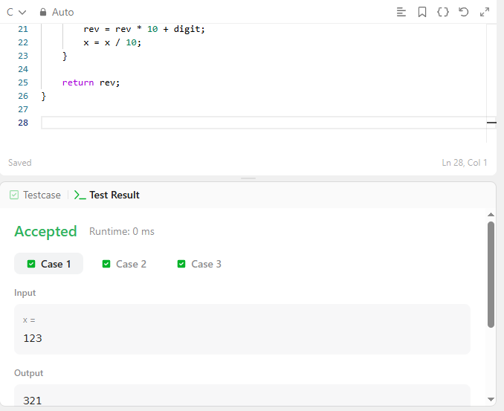

CODE –
int reverse(int x) {
int rev = 0;
int digit;

while (x != 0) {
digit = x % 10;

if (rev > 214748364 || rev < -214748364) {
return 0;
}

if (rev == 214748364 && digit > 7) {
return 0;
}

if (rev == -214748364 && digit < -8) {
return 0;
}

rev = rev * 10 + digit;
x = x / 10;
}

return rev;
}

LINK –
https://leetcode.com/problems/reverse-integer/

